LiFePO4 Battery Specification
Model: TB-BL1212F-S116B-00



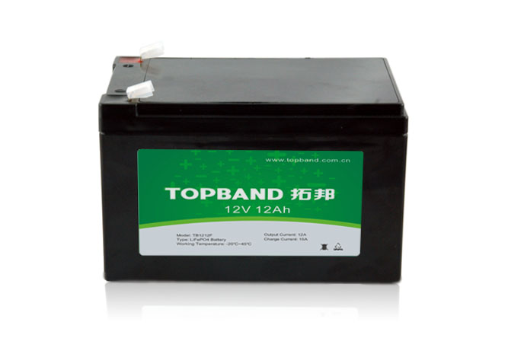

SHENZHEN TOPBAND NEW ENERGY CO.,LTD
Address: Topband Industrial Park,Liyuan Industrial Zone,Shiyan,Bao'an,Shenzhen, China,518108.
Web：ww.topband.com.cn

Registered | Tianmiaomiao | Customer
Checked | Dengzhaowei | Customer Model
Approved | Lili | Customer Reback:
Issued Date | 2017-04-20
Issued Version | V00
Document Number | XNY-01-14

Revisal record
REV. | Date | Contents | Revised | Remarks
V00 | 2017-04-20 | First issue | Tianmm

- General Information

This specification defines the performance of rechargeable LiFePO4 battery pack TB-BL1212F-S116B-00 manufactured by SHENZHEN TOPBAND NEW ENERGY CO.,LTD, describes the type, performance, technical characteristics, warning and caution of the battery pack. The battery pack support Bluetooth communication function. Through Android and IOS APP, can read the battery status and information. Especially due to the Android system’s openness, different smart phone manufacturer will have their own different Bluetooth hardware version and customized feature Android systems. So the APP may not work well on some smart phones(with Android system) due to compatible issue. It is necessary for the customer to confirm whether the phone is compatible for the APP.
- Specification(@Battery initial Temp25±5℃)
NO. | Items | Criteria | Remarks
2.1 | Rated Capacity | 12Ah
2.1 | Minimum Capacity | 11.4Ah
2.2 | Energy | 0.1536KWh
2.3 | Nominal Voltage | 12.8V
2.4 | Outgoing Voltage | ≥12.8V
2.5 | Internal resistance | ≤60mΩ
2.6 | Series parallel application | Series connection is prohibited
2.7 | Limited charge voltage | 14.6±0.2V
2.8 | Floating charge voltage | 13.8±0.2V
2.9 | Standard charge current | ≤6A
2.10 | Maximum charge current | 15A
2.11 | Standard discharge current | 10A
2.12 | Maximum discharge current | 15A
2.13 | Pulse discharge current | Withstand the 55A/3s
2.14 | Discharge cut-off voltage | 10V
2.15 | Dimension | Length: 151±2mm
2.15 | Dimension | Width: 98.5±2mm
2.15 | Dimension | Height: 95±2mm
2.16 | Weight | Approx: 1.6±0.2Kg
2.17 | Operating Temperature | Charging：0～45℃
2.17 | Operating Temperature | Discharging：-20～60℃
2.17 | Operating Temperature | Recommended operating temperature：15℃～35℃
2.18 | Self-discharge rate | Residual capacity：≤3%/month;≤15%/years
2.18 | Self-discharge rate | Reversible capacity：≤1.5%/month;≤8%/years
2.19 | Storage Temperature & Humidity Range | Less than 1 month：-20℃～35℃，45%RH～75％RH
2.19 | Storage Temperature & Humidity Range | Less than 3 months：-10℃～35℃，45%RH～75％RH
2.19 | Storage Temperature & Humidity Range | Recommended storage environment：  15℃～35℃，45%RH～75％RH
Long time storage:
If the battery need be stored for a long time, the voltage should be 13.2V(50%SOC), and stored in the condition as storage proposal. It need at least one charge & discharge cycle every six months
3. Test Conditions
3.1 Standard Test Conditions
3.1.1 Unless otherwise specified, all performance tests is required conducted at temperature 25℃±2℃, Humidity less than 45%~75%RH.
3.1.3 Unless otherwise specified, the tested product is required unused within two month after outgoing.
3.2 Standard Charge Mode
"Standard Charge" means at 25±2℃ charge to limit voltage with 0.33C constant current, then charge with constant voltage until current less than 0.02ItA.
3.3 Quick Charge Mode
" Quick Charge" means at 25±2℃ charge to limit voltage with 0.5 C constant current, then charge with constant voltage until current less than 0.02ItA.
3.4 Standard Discharge Mode
"Standard Discharge" means at 25±2℃ discharge to the cut-off voltage with 0.33C current.
3.5 Quick Discharge Mode
"Quick Discharge" means discharge to the cut-off voltage with 0.5C current.
4. Product Performance
NO. | Items | Criteria |  | Testing method
4.1 | Rated Capacity | 12Ah |  | Rest for 1 hour after fully charged, then discharge with 0.33C current until the battery reaches the discharge cutoff voltage. Repeat above process for three times, if the discharge time is not less than 120 minutes, you can stop and define the Discharging current*time value (Ah) as battery capacity.
4.2 | Minimum Capacity | 11.8Ah
4.3 | Internal resistance | ≤60mΩ |  | 50% battery SOC state frequency of 1 KHZ ac resistance tester
4.4 | Cycle life  （DOD100%） | ≥2000cycle |  | Discharge with the current of 0.33C until it can’t discharge, and then rest it for 1h. Charge the battery following CC(0.33C)/CV(14.6V) mode to full capacity, and then rest it for 1h. Repeat above process until full charged capacity is no more than 80% of normal value. Accumulated times is defined as cycle life.
4.5 | Discharge Temperature  Characteristics | -20℃ | ≥70% | At 25±5℃ discharge the battery with the current of 0.33C to the cut-off voltage and record charge capacity. Store the battery at various temperatures for 2h and discharge the battery with 0.33C to the cut-off voltage.
4.5 | Discharge Temperature  Characteristics | -0℃ | ≥80%
4.5 | Discharge Temperature  Characteristics | 25℃ | ≥100%
4.5 | Discharge Temperature  Characteristics | 55℃ | ≥95%
4.6 | Charge Retention ability | Residual  capacity≥80% |  | Charge the battery to full capacity and store it for 28days, and then discharge it with 0.33C to the cut-off voltage.
4.6 | Charge Retention ability | Recovery capacity≥90%
4.7 | Communication Function | Bluetooth |  | Through APP, user can read the battery system information such as voltage, current, SOC, temperature and so on.

5. Protective circuit specification
The batteries are supplied with a LiFePO4 Battery Management System (BMS)that can monitor and optimized each single prismatic cell during charge & discharge, to protect the battery pack overcharge, over discharge, short circuit. Overall, the BMS helps to ensure safe and accurate running.

NO. | Items | Content | Specification
5.1 | Over charge | Over-charge protection for each cell | 3.80±0.025V
5.1 | Over charge | Over-charge release for each cell | 3.60±0.025V
5.1 | Over charge | Over-charge release method | Under the release voltage
5.2 | Over discharge | Over-discharge protection for each cell | 2.0±0.025V
5.2 | Over discharge | Over-discharge release for each cell | 2.3±0.1V
5.2 | Over discharge | Over-discharge release method | Charge to recovery
5.3 | Over current | Discharge over current protection | 55A～65A
5.3 | Over current | Protection delay time | 100ms～200ms
5.3 | Over current | Over current release method | Release after cutoff the load.
5.4 | Short circuit | Do not short-circuit the electrodes | Designed For 65A～200A /300us
5.5 | Battery temperature | Charge over temperature | Protection @65±5℃
5.5 | Battery temperature | Charge over temperature | Release @50±5℃
5.5 | Battery temperature | Discharge over temperature | Protection @65±5℃
5.5 | Battery temperature | Discharge over temperature | Release @50±5℃
- Dimensional Drawing

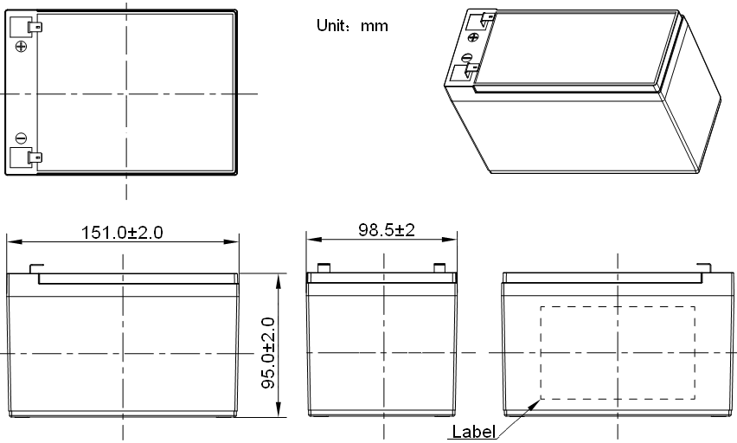

7. Transportation
* Based on the character of cell, proper environment for transportation of LiFePO4 battery pack need to be created to protect the battery.
* Battery should be stayed in the warehouse 15℃～35℃ where it’s dry, clean, shade, and well-ventilated.
* The battery should be stored in 50% SOC during transportation.
* The battery need to be charged every 6 months if out of use
* Keep the battery against dropping, turning over and serious stacking during loading.

8. Warning & Tips
Please read and follow the specification and caution remarks on battery surface before use the battery. Improper use may cause heat, fire, rupture, damage or capacity deterioration of the battery. SHENZHEN TOPBAND NEW ENERGY CO.,LTD. Describes is not responsible for any accidents caused by the usage without following our specification.
- The battery must be far away from heat source, high voltage, and avoid to be exposed in sunshine for long time.
- Never throw the battery into water.
- Do not put the battery in a charger or equipment with wrong terminals connected.
- Never connect the positive and negative of battery with metal.
- Avoid excessive physical shock or vibration. don't hit, fall, stamp on the battery
- Without the permission of the manufacturer and guidance, forbidden to remove or to assemble the battery
- Do not use the battery mixed with other different manufacturer, type, or model batteries.
- Keep the battery against high temperature. Otherwise it will cause battery heat, get into fire or lose some function and reduce the life.
- When battery run out of power, please charge your battery timely (≤15day).
- Please use the matched or suggested charger for this battery.
- If battery emit peculiar smell, heating, distortion or appear any abnormity during working or storage, please stop using and take it out from device.
- If the battery leaks and get into the eyes or skin, do not wipe, instead, rinse it with clean water and see doctor immediately.
- Please far away from children or pets.
- Do not put disuse battery into a fire or water.
- Series connection of this battery pack is prohibited
- Parallel connection of this battery pack is allowed under condition that voltage difference ≤0.2V,parallel numbers ≤4 groups, and operated by professionals.

9. Battery operation instruction
9.1 Charge and discharge
9.1.1 Charging current：Do not surpass the largest charging current that specification stipulated。
9.1.2 Charging voltage：Do not surpass the highest limited voltage that specification stipulated。
9.1.3 Charging temperature：within temperature scope that specification stipulated。
9.1.4 Charge with constant current, then with the constant voltage, no reverse charge, which is dangerous

9.1.5 Special note:
Short time doesn't affect the use of the battery overcharge too, but for a long period of time over discharge or over charge can affect the function of the battery failure, or the battery can't use permanent, appear serious safety hazards, need long time floating please use the recommended floating model specification.Battery when not in use for a long time, because of its own self-discharge characteristics can also cause discharge, to prevent the occurrence of a discharge, battery should maintain a certain capacity, maintain the voltage at 50% state of SOC.

10. Other Chemical Reaction
Because batteries utilize a chemical reaction, battery performance will deteriorate over time even
if stored for a long period of time without being used. In addition, if the various usage conditions
such as charge, discharge, ambient temperature, etc. are not maintained within the specified
ranges, the life expectancy of the battery may be shortened or the device in which the battery is
used may be damaged by electrolyte leakage. If the discharge time is much shorter than the
normal after full charged, even battery is charged correctly, and this may indicate it is time to
change the battery.

